Period Control Table

- MEC (period Close): this is the financial book close for the month. Typically, it is the same across the world and is determined by the Finance team. There will be further classification of time entry close, delivery close, finance AR close and Corporate close – corrections coming after each of these periods is handled differently including posting in JV.
- Delivery cutoff - date by which delivery teams should confirm
  - Time (Cost), Time for T&M / FCP revenue,
  - Time for Milestone using all available hours (less absent hours) and average rate for revenue,
  - Time * average rate for revenue in case actual data is not available
    - needed is the milestone confirmation in FP projects if it is ready for billing, BTG to adjust revenue both +ve and -VE (posting being handled in JV logic)
    - For Volume based on configuration actual numbers handed for that period in consideration
- Finance Cutoff: date by which AR/AP teams will do necessary approvals of the data from Delivery and also collate and post additional revenue and cost items (non Salary)
- Book Close: This is final step where CFO (FP&A) team will do review of books and make necessary JV for adjustment, additional costs, provisions etc and close the GL for reporting
- Accounting date: date on which posting to GL happens

Data field | Description | Field Type | Input Type | Source System | Mandatory  (Y/N) | Sample Data
Period of cycle | Month and year or any name for the cycle | Varchar | Input | - | Y
Status | Status of the period (Open/Closed) | Character | Auto Populated | - | Y
Start date | Start date of period | Date | Input | - | Y
End date | End date of period | Date | Input | - | Y
Accounting date |  | Date | Input | - | Y
Delivery cut-off date |  | Date | Input | - | Y
Finance cut-off date |  | Date | Input | - | Y
Book closure Date |  | Date | Input | - | Y
MEC period close date |  | Date | Input | - | Y
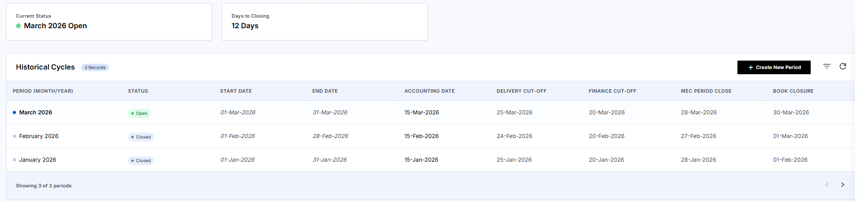

Rules:

- Status: by default, set up as close. Finance can open any of periods and close. Only one period can be left open at any time. All periods can be in close status. If accounting date is over, then status will be changed to close.
- Period – cannot have overlapping dates
- There should be an option to add new period
- Only finance will have access to add or edit

- Client Cutoff – Client Billing cycle – This is completely based on the MSA and need not be the same as corporate close – dates, day of the week, day of the month, advance billing, confirmation-based billing are different flavours and the same has to be handled differently in the invoice engine. This will have an impact on the billing (unbilled to billed conversation in Oracle and therefore in the invoice generation also
Table
Data field | Description | Field Type | Input Type | Source System | Mandatory  (Y/N) | Sample Data
Client name | Name of the client | LOV | Input
Client id | Unique id of the client | Varchar | Auto populated
Period of cycle | Month and year or any name for the cycle | Varchar | Input | - | Y
Status | Status of the period (Open/Closed) | Character | Auto Populated | - | Y
Start date | Start date of period | Date | Input | - | Y
End date | End date of period | Date | Input | - | Y
Client cut off date | Used for projects that don’t have a different date | Date | Input | - | Y

Rules:
- Used for projects that don’t have a different date
- Project / SOW Cutoff date (overrides MSA date if different)
- There should be option to edit period if necessary

Sample screen

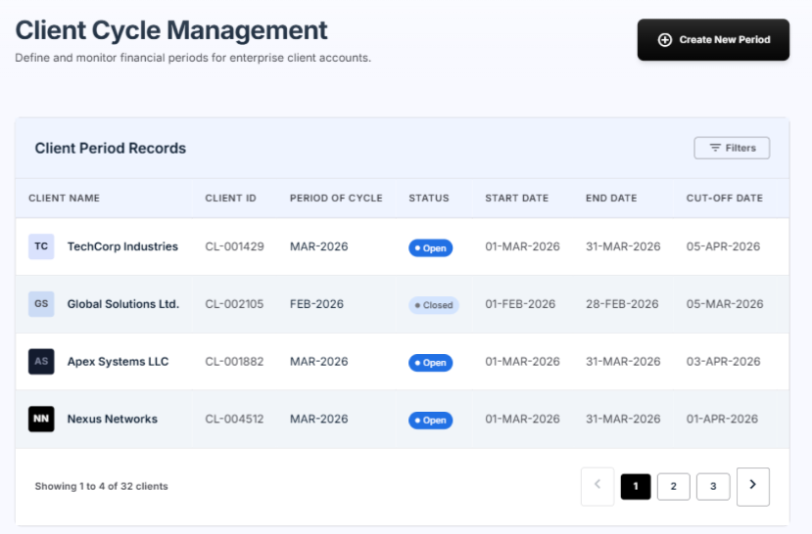

Timesheet related cut offs

Data field | Description | Field Type | Input Type | Source System | Mandatory  (Y/N) | Sample Data
Calendar Day | Day of the week | Character | Input | - | Y | Monday
Time | Time of the day | Time | Input | - | Y | 5 PM(local time of base location)
Contractor resubmit period | Number of days for which contract can resubmit defaulted timesheet | Number | Input | - | Y | 60 days

Rules:
- Calendar day and time is captured so that the job for employee timesheet defaulting will run based on this for the local time based on the base location of employee.

Payroll configuration

- Payroll cutoff: there will be a date based on different business and countries when payroll time entry is taken into consideration. Corrections to that value will be handled in the next pay cycle e.g BPS India and IT India can have different cutoff, US can have fortnightly cycles, other countries can have weekly cycles
Data field | Description | Field Type | Input Type | Source System | Mandatory  (Y/N) | Sample Data
Country |  | LOV | Input | Country master | Y | India
Type of period | Date range or Cut off | LOV | Input | - | Y | Date Range
Start date |  | Date | Input | - | Y if date range is selected
End date |  | Date | Input | - | Y if date range is selected
Payout date | Date on which salary will be credited | Date | Input | - | Y
Payroll cut-off date |  | Date | Input | - | Y if Cut off is selected
Description | Any remarks in terms of payroll cut off | Character | Input | - | Y
Salary Hold release period | Number of days for which employees can resubmit defaulted timesheet | Number | Input | - | Y | 60 days

Rules:

- One country can have more than one cut off date for a period.
- Salary hold release period – salary will be hold for employees who have defaulted timesheet. This period defines for how long employee can resubmit the timesheet. Applidable for employees
- There should not be overlapping dates

Scenario
Advance close
  - In exceptional business situations, Finance may decide to perform an Advance Close. For example, instead of following the regular closing cycle, the close process may be initiated on 28 June and completed by 2 July.
  - In such cases, the system shall allow the designated user to mark the period as an Advance Close in the Control Table. Once this flag is enabled, the system shall permit users to submit and process billing data for the configured advance close period, even though the standard month-end timeline has not been completed. This functionality provides the flexibility to accommodate exceptional business or financial reporting requirements without altering the defined billing period.

Client Cutoff(before 10th Aug(Net 30) ) > Book Close > Payroll cutoff(26th July) > Finance Cutoff (After 2nd Aug)> Delivery cutoff(weekly/ monthly after 2nd Aug)

MEC (period Close)(31st july )

Where adjustments is needed

